**CODE 1**

**PART 1: Social Interaction (3’)**

*Now, let’s talk about Dictionaries.*

1. Do you often use a dictionary?

2. What do you use dictionaries for?

3. What kinds of dictionaries do you think are most useful?

*Now, let’s talk about Sleep.*

1. How many hours do you sleep every day?

2. Is it necessary to take a nap every day? Why/Why not?

3. Do you like getting up early in the morning? Why/Why not?

**PART 2: Solution Discussion (4’)**

**Situation:**You are going to choose a roommate, which of the following qualities is the most important to you: ***tidiness****,* ***friendliness****,* ***quietness****?*

**PART 3: Topic development (5’)**

**Topic**: Historic buildings should be protected.

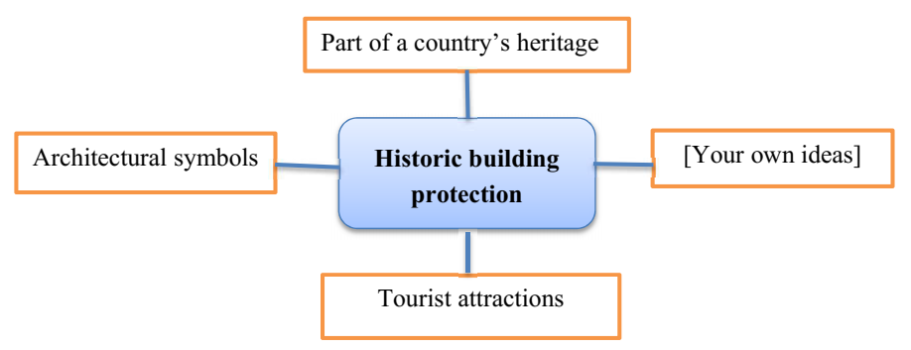

1. Do people in your country enjoy visiting historical places?

2. Do you think people should have to pay to visit these historic buildings? Why/Why not?

3. Who do you think should be responsible for the maintenance and repair of historic buildings?

**CODE 2**

**PART 1: Social Interaction (3’)**

*Let’s talk about Clothes and Fashion.*

* What type of clothes do you like wearing?
* **What clothes do you wear for different situations?**
* Do you think the clothes we wear say something about who we are?

*Let’s talk about Driving.*

* Are you able to drive?
* Do you think it’s necessary to learn to drive?
* What advice would you give people about safe driving?

**PART 2: Solution Discussion (4’)**

**Situation:** You are going to work for a big company and you want to improve some skills before starting your work*.* What kind of skill will you choose to learn first? ***computer skills, team work skills,* or *time management skills?***

**PART 3: Topic development (5’)**

**Topic:** More people are spending a lot of money and time on big weddings nowadays.

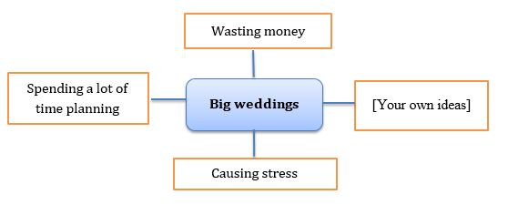

- Do you think big wedding celebrations make couples happier?

- Is it easy to accept an arranged marriage? Why?/ Why not?

- How are big weddings celebrated in Vietnam?

**CODE 3**

**Part 1: Social Interaction (3’)**

*Now, let’s talk about Habits.*

* What time do you go to work/to school every day?
* What do you usually do before going to work/to school?
* How do you travel to work/to school?

*Let’s talk about Transportation.*

* What is the most popular kind of transportation in your city?
* Are there many kinds of public transportation in your hometown?
* Do you want to have your own car? Why?/Why not?

**Part 2: Solution Discussion (4’)**

**Situation:** A mother wants to choose a TV programme for her 10-year-old daughter to watch. She is considering three programmes: ***wild life world, cartoons, game shows for children.*** Which do you think is the best choice?

**Part 3: Topic development (5’)**

**Topic**: Teenagers should be encouraged to join charity activities during summer holiday.

Helping people

Feeling better about themselves

[Your own ideas]

**Joining charity activities**

Getting more experiences

* What do teenagers in your country often do during their summer holiday?
* Is doing charity a popular summer activity for teenagers in your country?
* Do you think doing charity should become a compulsory summer activity for students? Why?/Why not ?